# Financial Forecasting System

**Concept of Recursion**

Recursion is a programming technique where a function calls itself in order to solve smaller instances of the same problem. It’s a way of breaking down complex problems into simpler, more manageable sub-problems.

**Components of Recursion:**

1. Base Case:

- The condition under which the recursion stops. It prevents infinite loops and provides a direct solution to the simplest form of the problem.

- Example: In the factorial calculation, the base case is when the input is 0 or 1, for which the factorial is 1.

2. Recursive Case:

- The part of the function where the problem is broken down into smaller instances of itself.

- Example: In factorial calculation, the recursive case is `factorial(n) = n * factorial(n-1)`.

Example: Factorial Calculation

Consider the factorial of a number n (denoted as n!), which is defined as:

- n! = n times (n-1)!

- Base case: ( 0! = 1 or 1! = 1)

Here’s how recursion can simplify this problem:

public class Factorial {

public static int factorial(int n) {

// Base case

if (n == 0 || n == 1) {

return 1;

}

// Recursive case

return n * factorial(n - 1);

}

public static void main(String[] args) {

int number = 5; // Example number

int result = factorial(number);

System.out.println("Factorial of " + number + " is " + result);

}

}

How Recursion Simplifies Problems

1. Divide and Conquer:

- Recursion breaks down a problem into smaller sub-problems, making it easier to manage and solve. Each recursive call works on a simpler version of the original problem.

2. Elegant Solutions:

- Recursive solutions can be more concise and easier to read compared to iterative solutions, especially for problems with a natural recursive structure (e.g., tree traversals, factorial calculation).

3. Natural Fit for Certain Problems:

- Some problems are inherently recursive. For example, the structure of a tree (each node can be seen as a subtree) or problems like the Fibonacci sequence or the Tower of Hanoi are naturally suited for recursive solutions.

4. Reduction of Complexity:

- For problems where the solution involves multiple stages or levels, recursion can simplify the solution process by allowing each function call to handle a specific stage of the problem.

Drawbacks and Considerations

- Stack Overflow:

- Deep recursion can lead to stack overflow errors if the recursion depth is too large. This is because each function call adds a new layer to the call stack.

- Performance Issues:

- Recursive solutions may have higher time complexity compared to iterative solutions due to repeated calculations. Techniques like memoization (caching results of recursive calls) can help optimize performance.

- Debugging Complexity:

- Recursive solutions can sometimes be harder to debug, especially if there are logical errors in the base case or recursive case.

Overall, recursion is a powerful tool when used appropriately, providing a clear and elegant way to solve problems that can be divided into smaller, similar problems.

**Time Complexity of the Recursive Algorithm**

The recursive method `calculateFutureValueMemoized` calculates the future value based on a recursive approach with memoization. Here's the analysis:

1. Time Complexity Analysis:

- Base Case: When `years == 0`, the method returns the `principal` value, which is a constant time operation O(1).

- Recursive Case: The recursive call `calculateFutureValueMemoized(principal * (1 + rate), rate, years - 1)` is made only once for each distinct value of `years`. Each call performs a constant amount of work (multiplying the principal by `(1 + rate)` and updating the memoization map), and the result is stored in the `memo` map.

- Memoization Impact: The memoization ensures that each value of `years` is computed only once. Thus, there are at most `n` unique recursive calls, where `n` is the number of years.

Overall Time Complexity: The time complexity is O(n), where n is the number of years. This is because each value of `years` is computed once and stored in the memoization map for constant-time retrieval.

2. Space Complexity Analysis:

- Stack Space: The recursive calls use stack space proportional to the depth of recursion. In the worst case, this is O(n), where n is the number of years.

- Memoization Space: The `memo` map stores one entry for each value of `years`, requiring O(n) space.

Overall Space Complexity: The space complexity is \(O(n)\), accounting for both the stack space and the space used by the memoization map.

Optimization to Avoid Excessive Computation

Although memoization significantly reduces the redundant computations, there are other ways to optimize the solution:

1. Use Iteration Instead of Recursion:

- If the problem can be solved using an iterative approach, it often avoids the overhead associated with recursive calls and stack usage.

- For calculating future value, an iterative approach is straightforward and efficient:

public static double calculateFutureValueIterative(double principal, double rate, int years) {

for (int i = 0; i < years; i++) {

principal *= (1 + rate);

}

return principal;

}

This iterative method avoids recursion altogether and has a time complexity of O(n) with a space complexity of O(1), making it more space-efficient.

2. Avoid Unnecessary Memoization:

- For this specific problem, memoization may be less critical due to the nature of the calculations. For a large number of periods, using an iterative approach might be more practical.

3. Optimize Calculation Method:

- For compound growth calculations, you can use the formula for compound interest directly:

public static double calculateFutureValueFormula(double principal, double rate, int years) {

return principal * Math.pow(1 + rate, years);

}

This method uses a mathematical formula to compute the future value in constant time O(1), avoiding recursion or iteration entirely. This is the most efficient method for this specific problem if precision and rounding issues are not a concern.

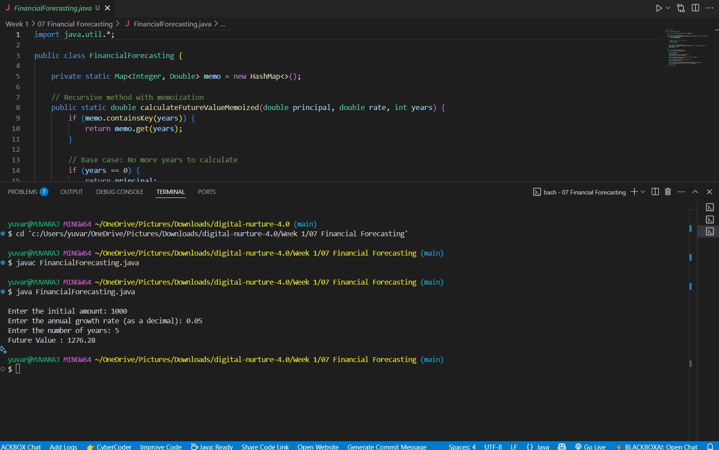OUTPUT: